My Rates - File Upload & Rate Card Creations

Rate Card Creations (FCL & LCL)

The Add New Rate interface allows users to publish new rates for FCL or LCL shipments. Key features include fields to specify origin, destination, via port, load type, and liner/carrier. Additional details like free days, service type, sailing date, transit time, and charges can be configured. Users can also add remarks, contract numbers, agent rates, and define the effective period for the rate. Once all details are input, rates can be published or saved as drafts.

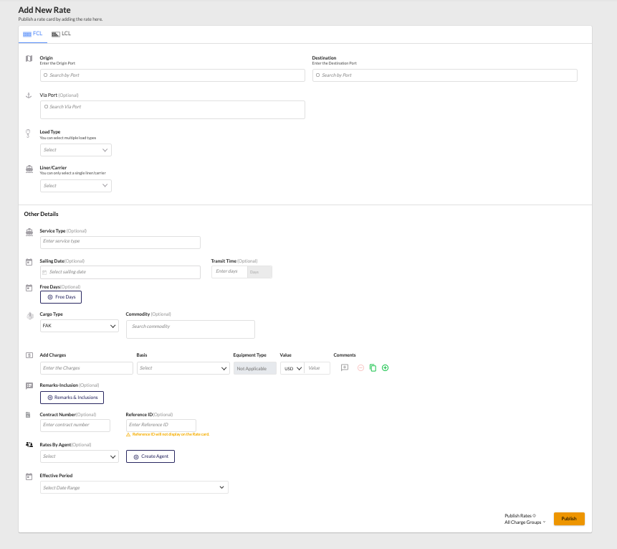

Once the user publishes the rates through the Add New Rate interface, the rates become available in the Rate Search module. This allows users to quickly search, filter, and review the published rates based on parameters like origin, destination, load type, and carrier.

Added rate cards can be deleted or modified, based on the change the Leg db will be updated. Search results will be based on the available db records

Standard Template (FCL & LCL)

Bulk Rate Upload Feature
- Purpose: Enables users to upload bulk rates via Freightify's predefined template format.
- Supported Legs: L2, L3, and L4 legs only.
- Template Details:
  - The template is a macro-enabled Excel file.
  - It includes a user form for streamlined rate entry.
  - Custom validations are integrated into the Excel workbook, ensuring data accuracy and compliance.
- Validation Process: Checks are triggered during the save stage of the workbook to validate input data.

Processing Flow
- Leg Splitting
  - Upon upload, the system automatically splits the rates into multiple legs (L2, L3, L4).
- Rate Injection Process
  - The split rates are processed through Freightify's existing rate injection pipeline to ensure seamless integration and validation within the system.
- Final Output
  - Successfully injected rates are made available in the rate search module for further usage.

→ File Browsing Popup
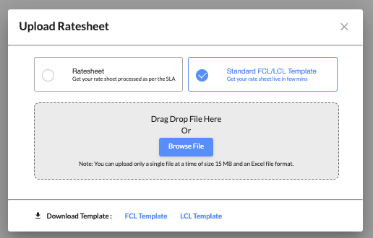

→ Preview screen
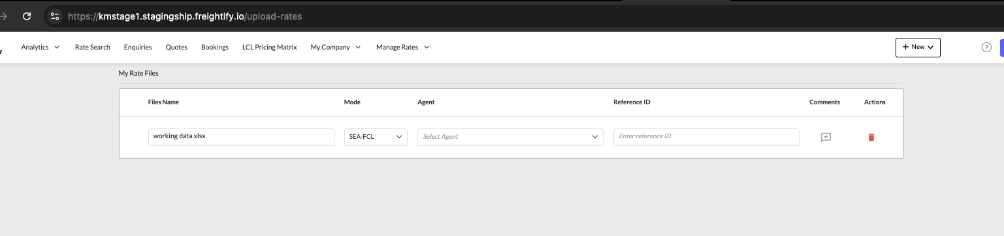

Domain Data Keys:
SHOW_ADDRATE_OPTIONS -> To show the edit, copy icon while adding rates

